ARTICLE TITLE
(Arial Narrow, normal, italic, 16, capital, centered)
Authors (Name and Surname) (Arial Narrow, normal, 10)

Affiliation of each author: university, institution, department, position, postal address and telephone number, email of main author (Arial Narrow, normal, 10)
Received: DD/MM/AA – Reviewed: DD/MM/AA -- Accepted: DD/MM/AA - DOI: https://dx.doi.org/10.6036 (To be completed by Editor)

ABSTRACT: →(Arial Narrow, Negrita, 10)  The abstract of the paper in English, will be of a maximum length of 300 words, better the shorter, clearer, more attractive and easier to understand even by the non-experts in that matter, highlighting the objectives of the work described rather than its scientific processes and always considering those objectives within the concept of the DYNA Journal. →(Arial Narrow, negrita, 9)  Keywords: 5-10 short words or short phrases identifying the content of the work for inclusion in national and international directories and databases →(Arial Narrow, negrita, 9) | RESUMEN: →(Arial Narrow, negrita, 10)  It is not necessary to complete. The Abstract in Spanish will be filled in by the editor.)

FUNDING
Institutions or organizations that finance the research and code that identifies it

1. - INTRODUCTION →(Arial Narrow, Bold, 12, capital)
It should include the rationale and purpose of the study with the current status of the technology addressed, making reference to strictly necessary bibliographic citations. It will not include data or conclusions of the work presented.
It is necessary to show in the Introduction the reasons that have motivated the work and the concrete and practical objectives that are intended with the text, whether it is research, good practices or the state of the art of technology. It is not enough to consider as an objective the description of a work carried out with no consequences other than those of its execution, even if it is technically correct. It must present definite perspectives that this work makes a positive contribution to engineering and industry. The language and terms used in this section should be understood by a broad spectrum of readers even if they are not experts. (Arial Narrow, normal, 10)


Fig. 1. Machine used in industry (Arial Narrow, normal, 10, italic)

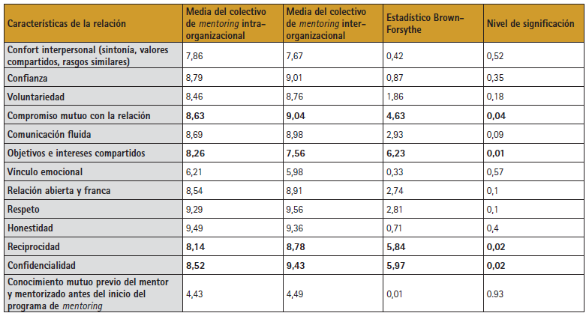
Table 1. Relation Characteristics → Arial Narrow, normal, 10, italic

Images, tables, schemes or graphs should preferably be placed as indicated. In case they need bigger size to be visible, they will be facilitated apart placing only the feet in the wished place. The font of the tables and figures will be Arial Narrow of size 9.
Equations: Use the Microsoft Word equation editor preferably. Try to make the equations compact by using in the sign (/), the exponential function as exp, or subscripts and superindexes. List the equations consecutively by placing the numbering in parentheses and aligning it with the left margin.
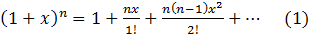
If they are numbered, put the number at the end of the line and take care of the consecutive numbering. If they exceed the length of the line, they will be provided separately, placing only the number in the desired place.
Units The recommended units are those of the metric system, in particular, the use of the International System of Units is suggested. The units from the English system can be used as secondary units (in parentheses).
Abbreviations: Abbreviations and acronyms that are not common the first time they appear in the text should be defined, even if they have already been defined in the abstract. Open. Do not use abbreviations in the title unless unavoidable.

2. - MATERIAL & METHODS →(Arial, bold, 12, capital)
Those applied and/or used for the accomplishment of the works will be presented with the precision that is convenient so that the reader understands and confirms the development of the investigation or the exposition of the good practices. Previously published methods should only be described briefly and the corresponding quotations should be provided, unless the authors have made modifications to the methods used in their case. If it is an original methodology, it is necessary to explain the reasons that led to its use and to describe its possible limitations. In this section, the language may be that which is scientifically or technically necessary.
Images, tables, schemes or graphs should preferably be placed as indicated in the previous section. If they require a larger size in order to be visible, they should be provided separately, placing only the feet in the desired place.
The equations will be expressed leaving lines of separation between the previous and the subsequent text. If they are numbered, give the number at the end of the line and take care of the consecutive numbering. If they exceed the length of the line, they will be provided separately, placing only the number in the desired place, as indicated in the previous section. (Arial Narrow, normal, 10)
Care should be taken that quotations referring to the bibliography throughout the text indicate the order number and identification as abbreviated as possible, and this when the fundamental ideas are contributed, without excessive repetitions that take up space and make the reading overwhelming.
This section admits other titles of the authors' choice, such as Development, Execution, etc. (Arial Narrow, normal, 10)

3. - RESULTS →(Arial, bold, 12, capital)
It will appear with a text from a logical sequence, and if they occur in tables, graphs, etc., the same data should not be repeated in it. Try to highlight the most important observations, describing, without interpreting or making value judgments, those made on the material and methods used.
The images, tables, schemes or graphs should preferably be placed as indicated in the previous section. If they require a larger size in order to be visible, they should be provided separately, placing only the feet in the desired place.
The equations will be expressed leaving lines of separation between the previous and the subsequent text. If they are numbered, give the number at the end of the line and take care of the consecutive numbering. If they exceed the length of the line, they will be provided separately, placing only the number in the desired place, as indicated in the previous section.
Care should be taken that quotations referring to the bibliography throughout the text indicate the order number and identification in the shortest possible way, and this when the fundamental ideas are contributed, without excessive repetitions that take up space and make the reading overwhelming. (Arial Narrow, normal, 10)

4. - DISCUSSION →(Arial, bold, 12, capital)
It will analyse, as briefly as possible, the results presented, relating them to the current situation or other studies with the advantages and disadvantages of each one. Do not repeat in any case data or ideas already commented.
Images, tables, schemes or graphs should preferably be placed as indicated in the previous section. If they require a larger size in order to be visible, they should be provided separately, placing only the feet in the desired place.
The equations will be expressed leaving lines of separation between the previous and the subsequent text. If they are numbered, give the number at the end of the line and take care of the consecutive numbering. If they exceed the length of the line, they will be provided separately, placing only the number in the desired place, as indicated in the previous section.
It is essential that in this section reference is made to the specific objectives and/or contributions to Engineering and Industry mentioned in the Introduction, as well as to their eventual real application and future continuity. The language and terms used must be understood by a broad spectrum of readers, even if they are not experts.
Care should be taken that quotations referring to the bibliography throughout the text indicate the order number and identification in the shortest possible way, and this when the fundamental ideas are provided, without excessive repetitions that take up space and make the reading overwhelming.
This section admits another title to be chosen by the authors, such as Conclusions. (Arial Narrow, normal, 10)

OTHER SECTIONS:
REFERENCES →(Arial, bold, 12, capital)
This section is not numbered. References should be numbered following discussion or acknowledgements, if any. DO NOT USE the Harvard citation system (author, year) for citations in the text, use reference numbering. The accuracy of bibliographic references is the responsibility of the author. If the references have DOI (Digital Object Identifier) it will be obligatory to include it in each one of them. It is possible to include as references accepted works, but not yet published, specifying the name of the publication followed by the expression "in press".
Care should be taken to verify that all citations placed in the text appear in the list of bibliographic references. References included in the text are presented at the end in numerical order in square brackets [1] according to the order of appearance in the text. A dot should follow parenthesis [2]. Multiple references may be cited with parentheses separated by a hyphen [1]-[3]. (Arial Narrow, normal, 8)
The citation system is detailed in Instructions for Authors of DYNA Journal.
As an example:
[1] Mindeguia JC, Pimienta P, Noumowé A, et al. “Temperature, pore pressure and mass variation of concrete subjected to high temperature — Experimental and numerical discussion on spalling risk”. Cement and Concrete Research. March 2010. Vol. 40-3. p.477–487. DOI: http://dx.doi.org/10.1016/j.cemconres.2009.10.011 → (Arial Narrow, normal, 9)
[2] Ye G, Liu X, De Schutter G, et al. "Phase distribution and microstructural changes of self-compacting cement paste at elevated temperature". Cement and Concrete Research. June 2007. Vol.37-6. p.978-987. DOI: https://doi.org/10.1016/j.cemconres.2007.02.011 → (Arial Narrow, normal, 8)

APPRECIATIONS (Arial, bold, 12, capital)
This section is not numbered and goes after the references. Only persons or entities that have made substantial contributions to the study but have not earned the qualification of author or collaborators will be thanked for their collaboration, and the author must have their written consent. In the case of funded research, authors are recommended to explicitly cite the source of funding. ( Arial Narrow, normal, 8)

FORMAT OF HEADINGS AND FONTS USED:
1.- TITLE SECTION 1 (Arial, bold, 12, capital)
1.1.- TITLE SECTION 2 (Arial, normal, 12, capital)
1.1.1.- Title paragraph 3 (Arial, bold, 11, lowercase)
1.1.1.1.- Title 4 (Arial, normal, 11, lower case)
Article text (Arial Narrow, normal, 10, lowercase)

OTHER INDICATIONS:
This template contains the default settings for margins, styles, spacing,... To use this template open it and save it with a new name. From that moment on, you will be able to replace the images and the text with the content of your article, keeping the necessary styles and formatting.
To see the styles of this template, click on the Start menu and then on "Change styles". The formats of the article will appear with a name starting with an underscore:
- _TIT_ART_INGLES: Format of article title
- _CAJ_AUTORES: Format of authors' information
- _CAJ_ABSTRACT: Format for article summary
- …

